ACTIVITY
TOOL: R Programming RegisterNo:192424189
Name: Dhanusha D Date:20-07-2026 COURSE: Data Handling and Visualization Code: DSA0604 CASE STUDY 1: Hospital Patient Admission Analysis

R PROGRAM:
hospital <- data.frame(
Department = c("Cardiology","Neurology","Pediatrics","Orthopedics","Emergency"), Admissions = c(250,180,320,210,400)
)
print(hospital) ggplot(hospital, aes(x = Department,
y = Admissions,
fill = Department)) +

geom_bar(stat = "identity") +

labs(
title = "Hospital Patient Admissions by Department", x = "Department",
y = "Number of Admissions"
) +
theme_minimal()hospital$Month <- c("Jan","Jan","Jan","Jan","Jan")ggplot(hospital, aes(x = Month,
y = Admissions,
fill = Department)) +

geom_bar(stat = "identity") + labs(
title = "Stacked Department-wise Admissions",

x = "Month",
y = "Admissions"
) +
theme_minimal()ggplot(hospital, aes(x = Admissions)) +
geom_histogram( binwidth = 50, fill = "skyblue", color = "black"
) +
labs(
title = "Distribution of Patient Admissions", x = "Admissions",
y = "Frequency"
) +

theme_minimal()ggplot(hospital, aes(x = "",
y = Admissions)) +

geom_boxplot(fill = "orange") +

labs(
title = "Box Plot of Patient Admissions", x = "",
y = "Admissions"
) +

theme_minimal()ggplot(hospital, aes(area = Admissions,

fill = Department, label = Department)) +

geom_treemap() +

geom_treemap_text( colour = "white", place = "centre", grow = TRUE
) +

labs(
title = "Treemap of Hospital Admissions"
)
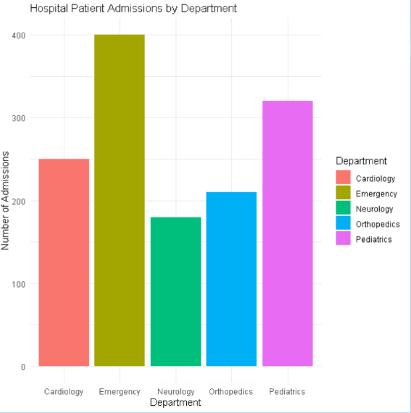

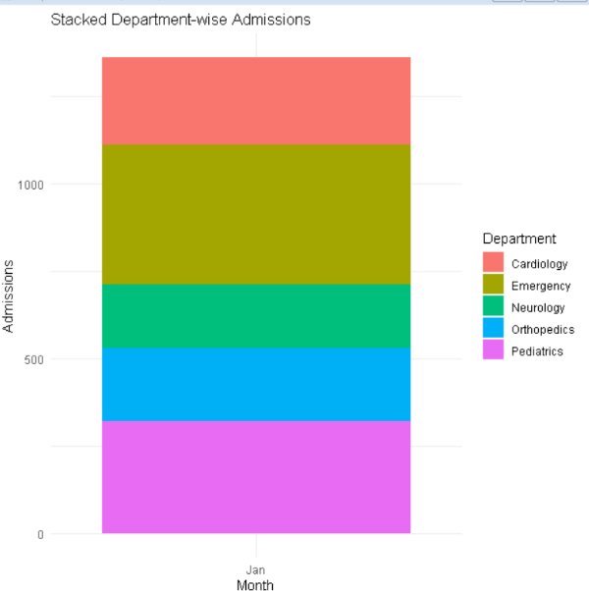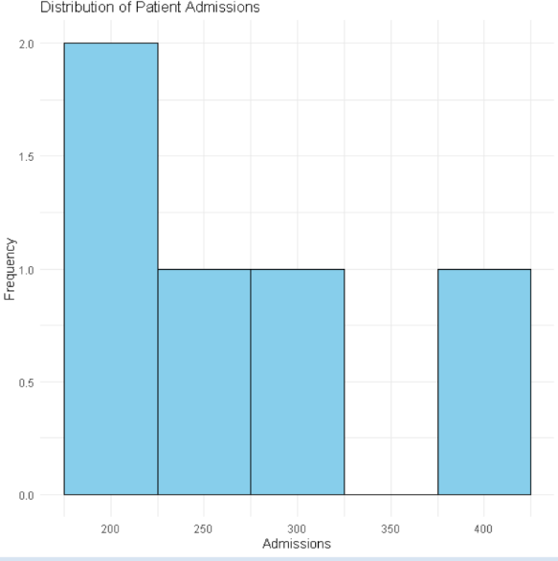
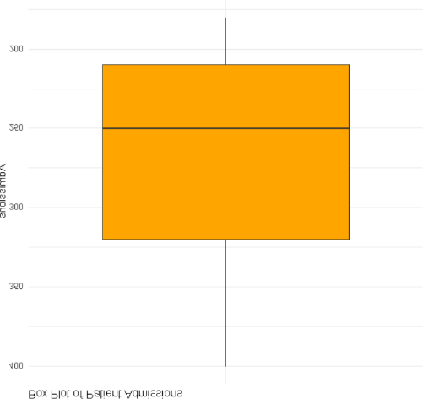
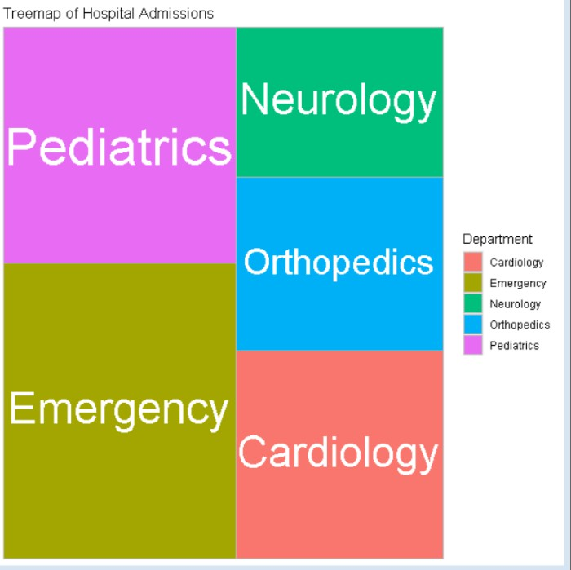

CASE STUDY-2 E-Commerce Customer Spending Behaviour. R PROGRAM:
library(ggplot2)

library(dplyr)

customer <- data.frame( CustomerID = 1:15,
PurchaseAmount = c(1200,2500,1800,3200,900,4100,2750,1500,3800,2100,950,4300,3000,1600,2400),
OrderFrequency = c(5,8,6,10,3,12,9,5,11,7,2,13,10,4,8),
Category = c("Electronics","Clothing","Electronics","Home","Books", "Electronics","Home","Books","Clothing","Electronics", "Books","Home","Electronics","Clothing","Home")
)

print(customer)

ggplot(customer,
aes(x = PurchaseAmount)) + geom_histogram(binwidth = 500,
fill = "skyblue", color = "black") +
labs(
title = "Histogram of Customer Purchase Amount", x = "Purchase Amount ($)",
y = "Frequency"
) +
theme_minimal()

ggplot(customer, aes(x = Category,
y = PurchaseAmount, fill = Category)) +
geom_violin(trim = FALSE) +

labs(
title = "Violin Plot of Purchase Amount by Category", x = "Product Category",
y = "Purchase Amount ($)"
) +
theme_minimal()

ggplot(customer, aes(x = Category,
y = PurchaseAmount, fill = Category)) +
geom_boxplot() + labs(
title = "Box Plot of Customer Spending", x = "Product Category",
y = "Purchase Amount ($)"
) +
theme_minimal()

ggplot(customer,
aes(x = PurchaseAmount, fill = Category)) +
geom_density(alpha = 0.5) + labs(
title = "Density Plot of Purchase Amount", x = "Purchase Amount ($)",
y = "Density"
) +
theme_minimal()

category_sales <- customer %>% group_by(Category) %>% summarise(TotalPurchase = sum(PurchaseAmount))

ggplot(category_sales, aes(x = Category,
y = TotalPurchase, fill = Category)) +
geom_bar(stat = "identity") + labs(
title = "Total Purchase Amount by Category", x = "Product Category",
y = "Total Purchase Amount ($)"
) +
theme_minimal()

cat("\nEvaluation:\n")
cat("Histogram shows spending distribution.\n")
cat("Violin plot shows spending distribution across categories.\n") cat("Box plot identifies high-value customers and spending variability.\n") cat("Density plot shows purchasing trends.\n")
cat("Bar chart compares total purchase by category.\n")

cat("\nRecommendation:\n")
cat("Box Plot is the most appropriate visualization because it clearly identifies high-value customers, spending variability, median values, and outliers for business decision-making.\n")

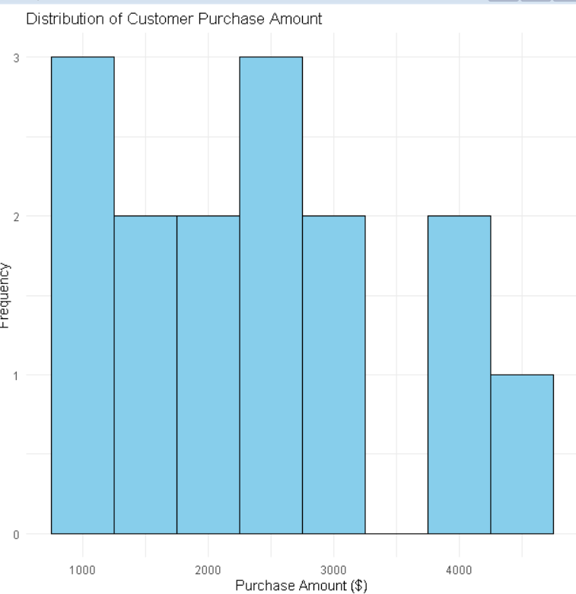
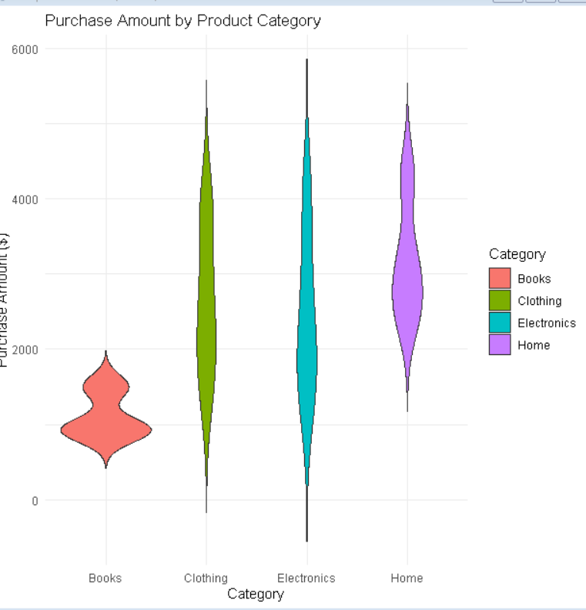

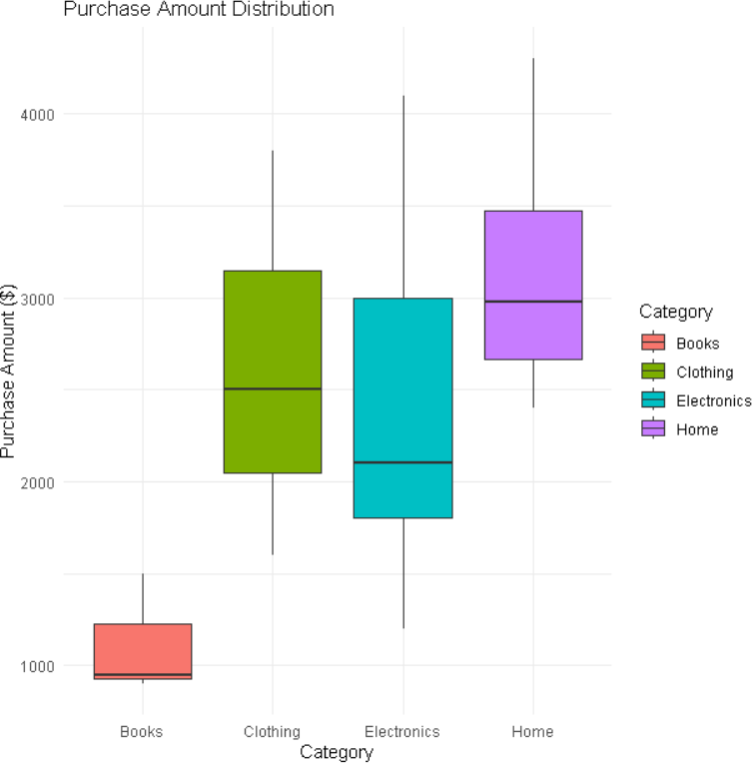
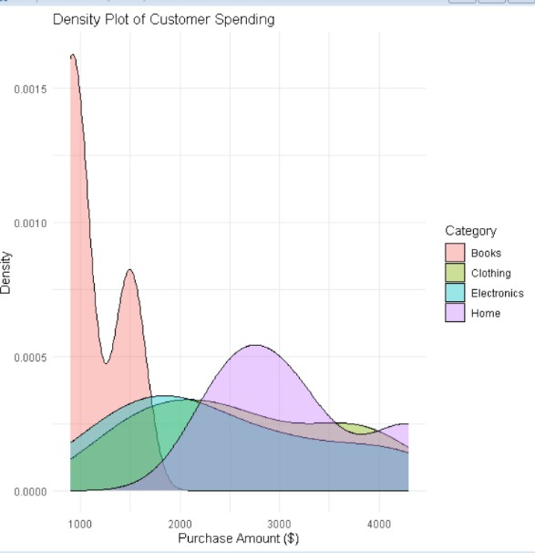
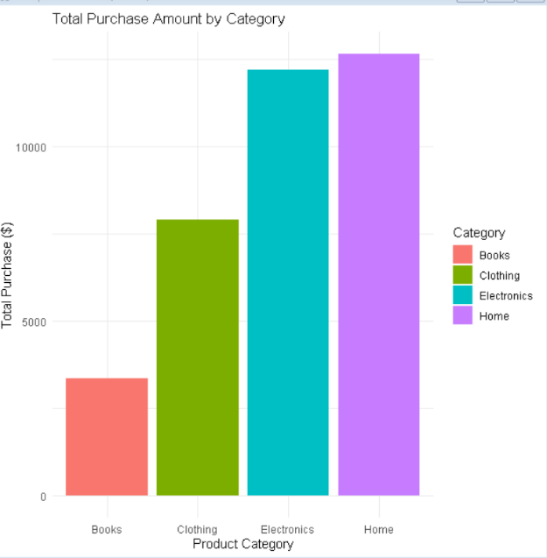

CASE STUDY -3

University Examination Performance Dashboard R PROGRAM:
library(ggplot2) library(dplyr)
students <- data.frame( StudentID = 1:20,
Department = c("CSE","CSE","CSE","CSE","ECE","ECE","ECE","ECE",
"MECH","MECH","MECH","MECH","AI","AI","AI","AI",

"IT","IT","IT","IT"),
Class = c("A","A","B","B","A","A","B","B",
"A","A","B","B","A","A","B","B", "A","A","B","B"),
Marks = c(92,85,78,88,75,81,69,90,72,65,80,76,95,91,89,84,87,82,79,93)
)

print(students)

ggplot(students,
aes(x = Department, y = Marks,
fill = Department)) + geom_boxplot() +
labs(title = "Marks Distribution by Department", x = "Department",
y = "Marks") + theme_minimal()

ggplot(students, aes(x = Marks,
fill = Department)) + geom_histogram(binwidth = 5,
color = "black", alpha = 0.7) +
labs(title = "Distribution of Student Marks", x = "Marks",
y = "Frequency") + theme_minimal()

class_avg <- students %>% group_by(Class) %>% summarise(AverageMarks = mean(Marks))

ggplot(class_avg, aes(x = Class,
y = AverageMarks, fill = Class)) +
geom_bar(stat = "identity") + labs(title = "Average Marks by Class",
x = "Class",
y = "Average Marks") + theme_minimal()

top_students <- students %>% arrange(desc(Marks)) %>% head(10)

ggplot(top_students,
aes(x = reorder(as.factor(StudentID), Marks), y = Marks,
fill = Department)) + geom_bar(stat = "identity") + coord_flip() +
labs(title = "Top Performing Students", x = "Student ID",
y = "Marks") + theme_minimal()

dept_avg <- students %>%

group_by(Department) %>% summarise(AverageMarks = mean(Marks))

ggplot(dept_avg,
aes(x = Department, y = AverageMarks, group = 1)) +
geom_line(color = "blue", linewidth = 1) + geom_point(size = 3, color = "red") + labs(title = "Average Marks by Department",
x = "Department",
y = "Average Marks") + theme_minimal()

cat("\nEvaluation:\n")
cat("1. Box Plot identifies score distribution and outliers.\n") cat("2. Histogram shows the distribution of student marks.\n") cat("3. Bar Chart compares average marks across classes.\n") cat("4. Horizontal Bar Chart identifies top-performing students.\n") cat("5. Line Chart compares average marks across departments.\n")

cat("\nDashboard Improvements:\n") cat("1. Add department and class filters.\n")
cat("2. Display KPIs such as highest, lowest and average marks.\n") cat("3. Highlight top performers with different colors.\n")
cat("4. Include interactive tooltips for student details.\n") cat("5. Add trend analysis and pass percentage charts.\n")

cat("\nRecommendation:\n")

cat("The Box Plot is the most effective chart for academic decision-making because it clearly shows score distribution, median, variability and outliers across departments, while the Bar Chart effectively compares average performance between classes.\n")
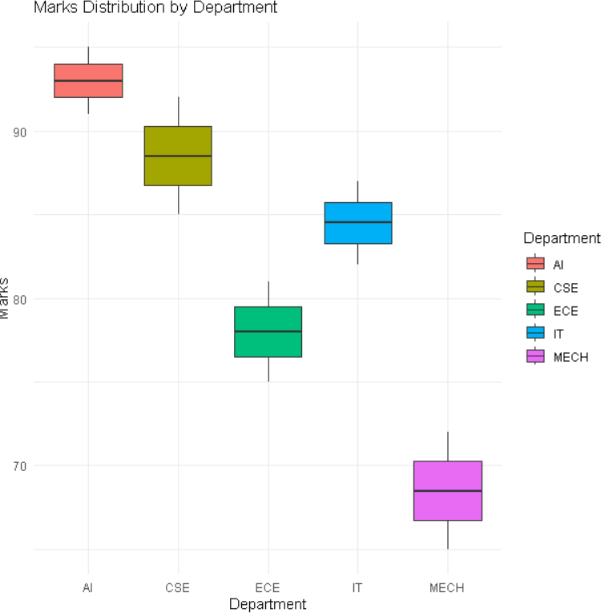
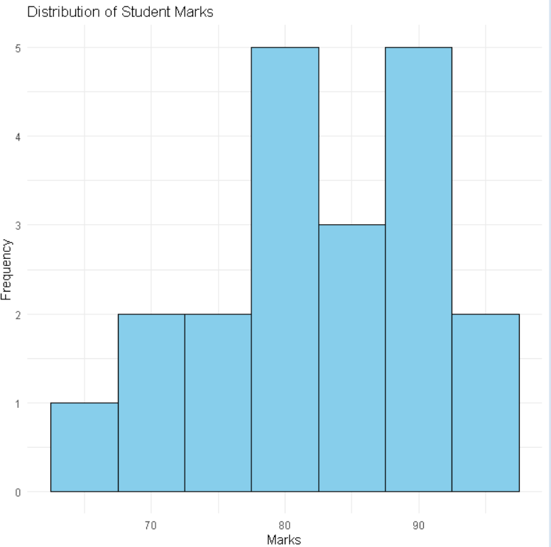

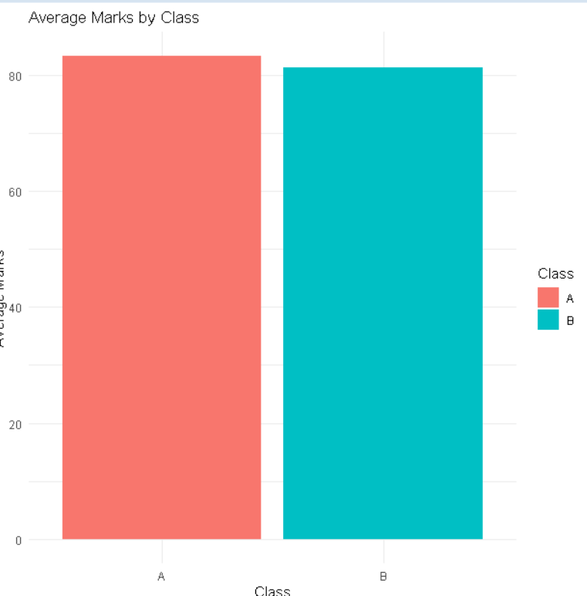
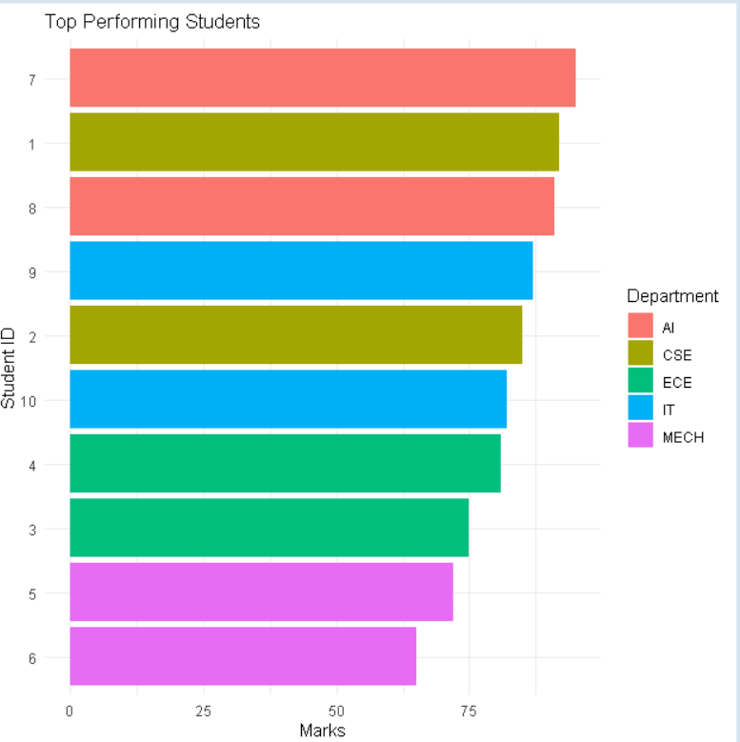

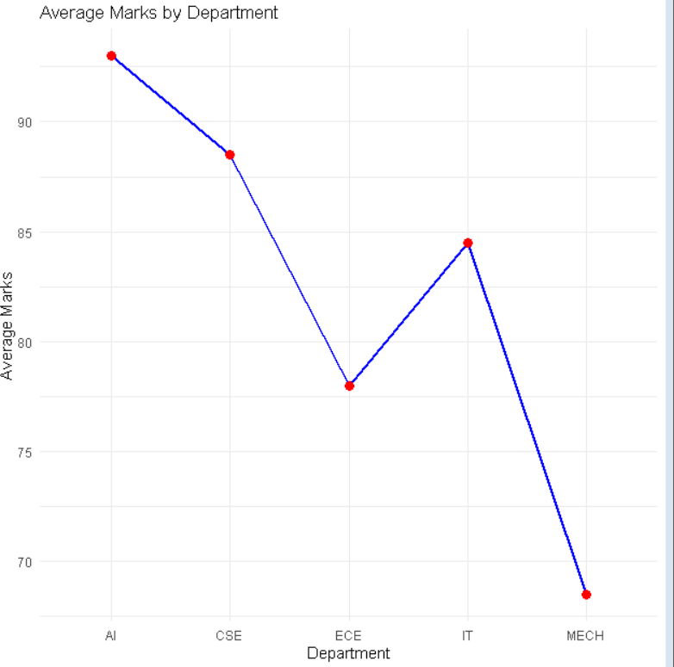

CASE STUDY -3 Climate and Rainfall Distribution Study R PROGRAM:
library(ggplot2) climate <- data.frame(
Month = c("Jan","Feb","Mar","Apr","May","Jun","Jul","Aug","Sep","Oct","Nov","Dec"),
City = c("Chennai","Delhi","Mumbai","Bangalore","Hyderabad","Chennai","Delhi","Mumbai","Ba ngalore","Hyderabad","Chennai","Delhi"),
Rainfall = c(120,150,180,220,300,350,400,380,320,250,180,140), Temperature = c(28,30,32,29,31,27,26,25,27,28,29,30),
Humidity = c(65,60,70,68,72,80,85,88,82,75,70,68)
)
print(climate)
ggplot(climate, aes(x = Rainfall)) +
geom_histogram(binwidth = 40, fill = "skyblue", color = "black") + labs(title = "Histogram of Monthly Rainfall",
x = "Rainfall (mm)", y = "Frequency") +
theme_minimal()

ggplot(climate, aes(x = Rainfall)) + geom_density(fill = "lightgreen", alpha = 0.5) + labs(title = "Density Plot of Rainfall",
x = "Rainfall (mm)", y = "Density") +
theme_minimal()

ggplot(climate, aes(x = City, y = Rainfall, fill = City)) + geom_boxplot() +
labs(title = "Rainfall Distribution Across Cities", x = "City",
y = "Rainfall (mm)") + theme_minimal()

ggplot(climate, aes(x = Month, y = Rainfall, fill = Month)) + geom_bar(stat = "identity") +
labs(title = "Monthly Rainfall", x = "Month",
y = "Rainfall (mm)") + theme_minimal() cat("\nEvaluation:\n")
cat("Histogram shows rainfall distribution.\n") cat("Density plot represents climate distribution.\n")
cat("Box plot identifies rainfall variability and outliers across cities.\n")
cat("Bar chart clearly shows seasonal rainfall variation.\n")cat("\nRecommendation:\n")
cat("Bar Chart is best for seasonal rainfall variation because it compares monthly rainfall clearly. Box Plot is most suitable for environmental researchers since it highlights rainfall variability and outliers across cities. Density Plot effectively represents overall climate distribution.\n")

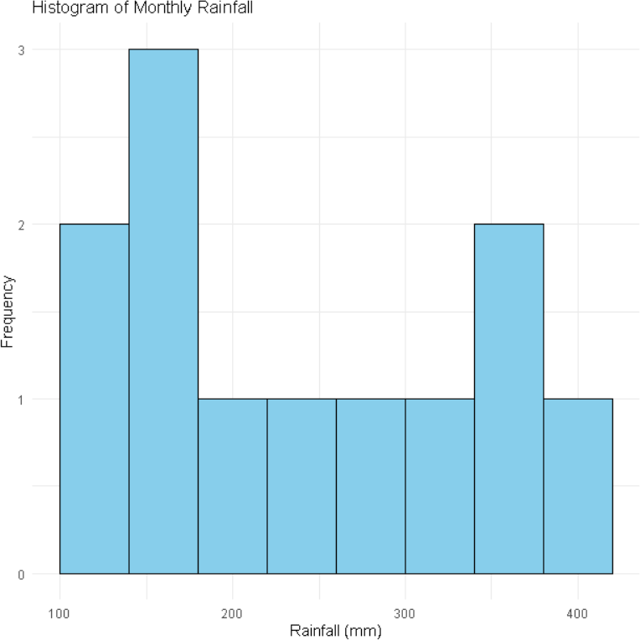
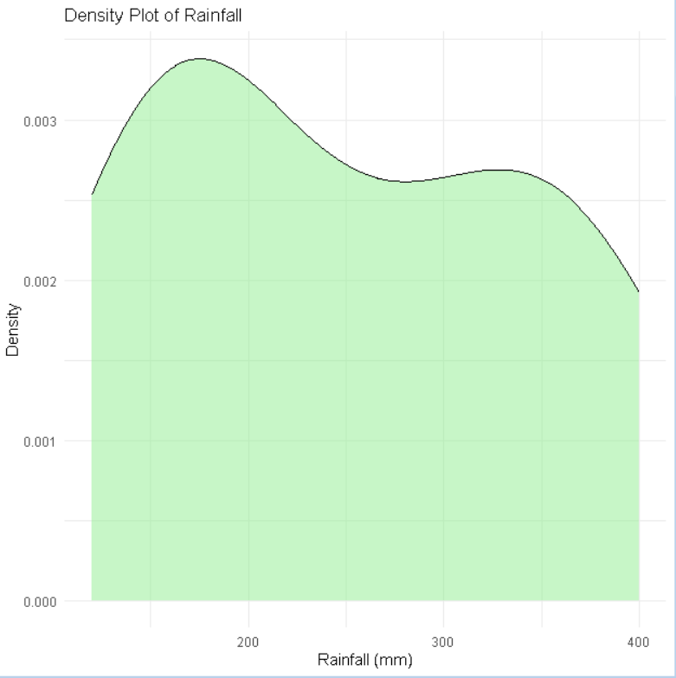

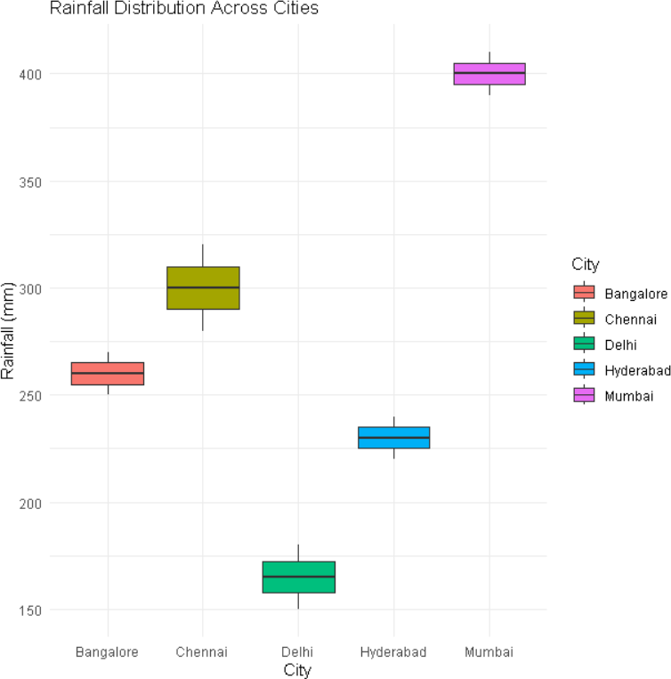
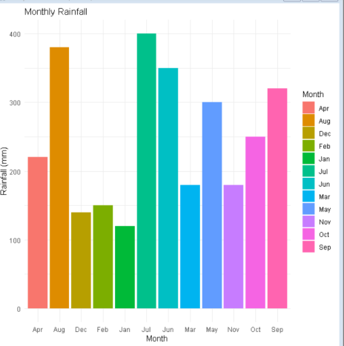

CASE STUDY -5

Bank Loan Risk Assessment R PROGRAM:
library(ggplot2) loan <- data.frame(
CustomerID = 1:10,
LoanAmount = c(50000,80000,120000,150000,90000,110000,70000,130000,95000,160000),
RepaymentHistory = c("Good","Good","Average","Poor","Good","Poor","Average","Good","Poor","Average"),
Income = c(30000,45000,60000,80000,50000,75000,90000,65000,40000,85000),

CreditScore = c(620,680,720,790,700,760,810,730,650,800)
)
print(loan)
ggplot(loan, aes(x = LoanAmount)) +
geom_histogram(binwidth = 20000, fill = "skyblue", color = "black") + labs(title = "Loan Amount Distribution",
x = "Loan Amount", y = "Frequency") +
theme_minimal()
ggplot(loan, aes(x = RepaymentHistory, y = LoanAmount, fill = RepaymentHistory)) + geom_boxplot() +
labs(title = "Loan Amount by Repayment History", x = "Repayment History",
y = "Loan Amount") + theme_minimal()
ggplot(loan, aes(x = Income, y = CreditScore)) + geom_point(color = "blue", size = 3) + labs(title = "Income vs Credit Score",
x = "Income",
y = "Credit Score") + theme_minimal()
ggplot(loan, aes(x = RepaymentHistory, fill = RepaymentHistory)) + geom_bar() +
labs(title = "Customer Segments by Repayment History", x = "Repayment History",
y = "Number of Customers") + theme_minimal() cat("\nEvaluation:\n")
cat("Histogram shows loan distribution and skewness.\n")
cat("Box Plot identifies outliers and compares loan amounts across repayment history.\n")

cat("Scatter Plot shows the relationship between income and credit score.\n") cat("Bar Chart compares customer segments by repayment history.\n")

cat("\nRecommendation:\n")
cat("The Box Plot is the most suitable visualization for a management dashboard because it clearly highlights risk patterns, skewness, and outliers, supporting better loan approval decisions.\n")
